translate5 – Guide to the Editor for Translators and Reviewers

Contents
1. About the translate5 Editor 2
2. Logging in and getting started 2
3. Task Overview 3
4. Editor view 6
Panels 7
Buttons 9
Columns 10
5. Editing a task 12
Editing tools 13
Search and replace 13
Bookmark 14
Quality management measures 14
Managing repetitions 15
Terminology, style, grammar, and spelling 16
6. Leaving / Finishing the task 17
7. Logging out 17
Appendix I 18
Appendix II 19

1. About the translate5 Editor
The translate5 Editor is part of the translate5 open-source translation management system. It enables you to translate, check and edit documents online in your browser.

2. Logging in and getting started

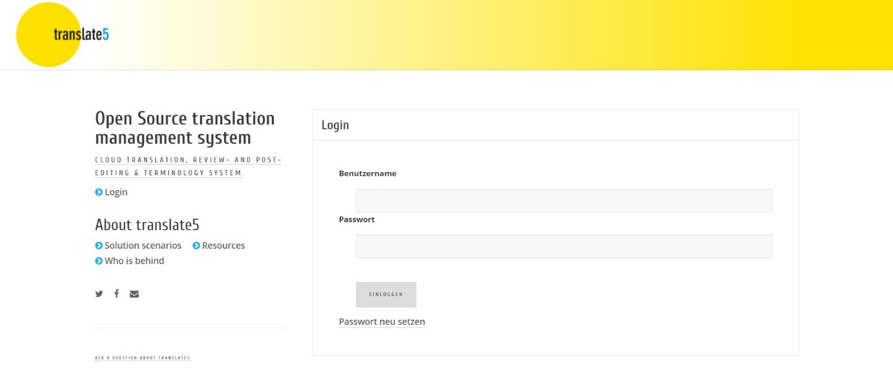
Type in your username and password and click on Login or press “Enter” on your keyboard.
Once logged in, the Task Overview screen appears.
By the way: If you want to point someone else to a certain segment of a certain task, you can just copy the URL from your browser, while editing the segment in question, and send it to the person you want to inform. After login translate5 will then open the segment in question in the corresponding task, granted the user has necessary rights.

3. Task Overview
The Task Overview provides you with a list of your tasks and the relevant specifications.
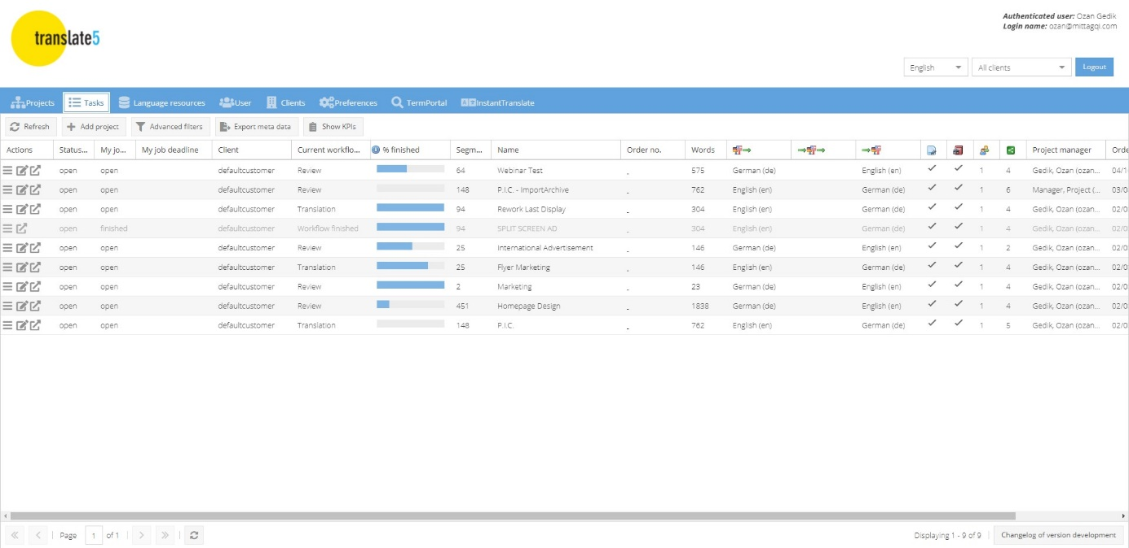
The Task Overview consists of the following columns. Depending on the configuration of your translate5 instance, some of these columns may be hidden or even completely disabled. Hidden columns can be shown by hovering over the column header, clicking on “Columns” in the drop-down that appears, and then activating the column in question.

Actions | You can choose from three options in the pop-up menu : Open task (read-only mode), Edit task and Finish task.  You can also open and edit the selected task directly by clicking on the right. For project managers additional actions exist.
Status (task) | This column shows you whether a task is open, in progress or finished.
My job status | If a task is assigned to several translators or reviewers, your job status is displayed here.
My job deadline | Indicates whether a specific deadline has been set for completing your part of the task.
Client | Client company name.
Current workflow step | Indicates the workflow step the task has reached so far.
% finished | This column shows the progress of the task as a percentage. It always refers to the current workflow step.
Segment count | Total number of segments in a task.
Name | Project name.
Order no. | Project order number.
Words | The total word count for the task.
Files | The number of files included in the task.
Source language | The language of the original document for translation.
Pivot language | A further language to be used as a reference if the reviewer is not familiar with the source language. Only relevant for review tasks.
Target language | The language into which the document is to be translated.
Reference files | This column is ticked if reference files are provided.

Terminology | Indicates whether customer-specific terminology is available.
Users | The number of users who are working on the task.
Project manager | Your contact person in project management.
Order date | The date when the review task was assigned.
100 % matches can be edited | Here you can see whether it is possible to edit 100 % matches.
Translation job | This column is ticked if this is a translation task, i.e., all target language segments were empty at the time of import. An empty column indicates a review task.
Locked segments (SDLXLIFF files only) | This column is ticked if the imported file contains locked segments that are also locked in Trados Studio platform. This is only relevant, when using SDLXLIFF as import format.
Source language editable | This column indicates whether it is permissible to edit the source language.

4. Editor view
Select the task you want to review in the Task Overview. To open it, either double-click on the task or go to the Actions column and click on Edit task or .

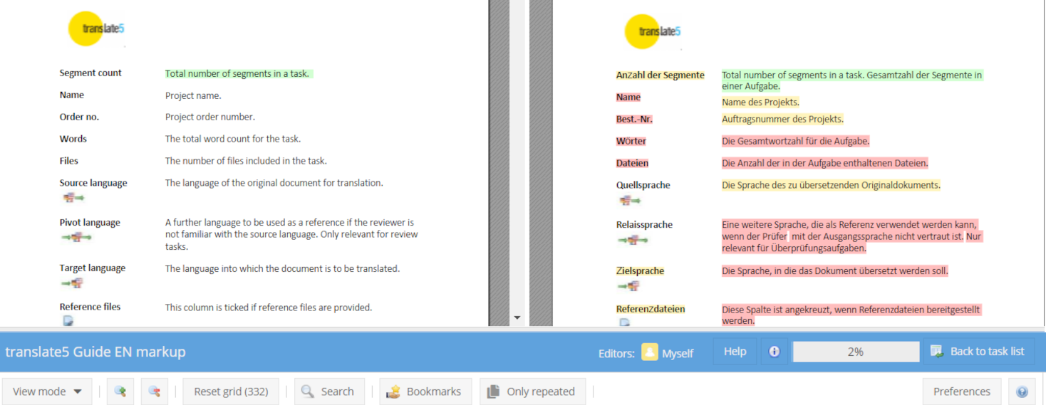
Once you have opened your task, the Editor View appears. Across the top border of the editor (coloured blue in the standard theme) you will see the following:
- Task/project name
- Help button (click here to access the YouTube tutorial video)
- Info icon (shows details of user, login name and task name)
- Status bar (indicating progress in the task as a percentage)
- Back to task list button (exit the Editor and return to the Task Overview)

Panels
The panels on the left, right, and bottom of the screen can be collapsed or expanded by clicking on the arrow in the top-right corner of each respective panel.
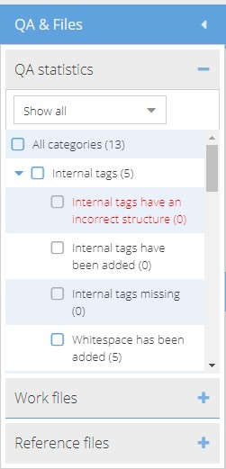
The QA & Files panel on the left lets you see which individual files are assigned to the task. Double clicking on a particular file takes you to the first segment of that file in the review document.
The panel is divided into three sections:
- QA statistics: Shows a breakdown of errors
detected.
- Work files: These are the files to be
translated/edited.
- Reference files: A list of PDFs and other original files for reference purposes.
The arrangement of the files can be adjusted by drag and drop. This also changes the order of the segments in the review document and, in case of a folder hierarchy, also the location of the file in its folder.

The Segment-editor panel is located on the right side of the Editor panel. Segment editor icons relevant to modifying the currently active text segment are found at the top. Hover your mouse over each icon to see a description of each editor action and the associated keyboard shortcut.
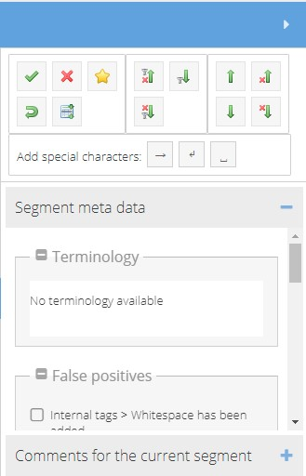
You can also click on the  icon to see a full list of keyboard shortcuts.
It is also possible to add special characters (tab, soft return, and non-breaking space).
If the project manager has made this function available, the segment meta data includes any associated terminology sources, the assignment of Manual QA (inside segment) and statistics, manual Status or Manual QA (complete segments) quality ratings. You can also add and view comments.
The Matches and concordance search panel at the bottom of the screen displays the results of all language resources associated with the task (if any are associated).

Buttons
The buttons across the top of the Editor View let you
- define the degree of detail for the view mode (detailed/normal; hide/show formatting tags; interface language; hide/show tracked changes)
- increase/decrease the font size
- reset the grid after filtering
- search for/replace a term string
- show bookmarked segments
- show only repeated segments

The Preferences button on the right lets you define how to manage segment repetitions (see Ch. 5.)
Next to this is the icon. Click to access a list of keyboard shortcuts.

Columns
You can resize and move the columns as you wish. Your customizations persist until you change them or select one of the explicit view modes (see above). Click on the downward arrow in any column header (appears when you mouse over the header) to set various column options:
- “Sort” allows you to sort the contents of the selected column in ascending or descending order.
- Depending on the type of column, use “Filter” to filter according to specific criteria, e.g., by entering a segment number, processing status, match rate or text fragment.
- The “Columns” option lets you show or hide additional columns.
Click the 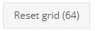button to reset the grid after sorting or filtering. The number in brackets on the button shows you the number of segments in your current filter setting.

Standard columns:
(detailed view – the normal view shows fewer columns, but they can be shown at any time by clicking on the arrow of a column header, going to “Columns” to see all available columns)
No. | Segment number in the review document.
Edited at | Workflow step at which segment was last edited, e.g., translation or review.
Processing status | This indicates, for example, whether a segment has been translated or edited, when and by whom.  (See Appendix I for a full list.)
Match rate | The match rate shows whether the translation is a 100 % match, fuzzy-match, or new translation.
Match rate type | Shows where the segment content comes from, e.g., from a TM.  (See Appendix II for a full list.)
Source text | The text to be translated is displayed here.
Pivot language | The pivot language is displayed in this column if one has been set.
Target text (at time of import) | This column shows the version of the translated text at the time of import for review.
Target text | This is where the actual translation or review workflow step takes place. The translation or changes and corrections to the translation are entered here.
Comments | Click on the icon in the "Comments" column, if shown, to add and view comments to the opened segment. (Alternatively, you can add a comment via the Segment-editor panel.)
Last editor | The name of the last person to edit the segment.
Blocked | Indicates segments which may not be edited.
Bookmarks | Indicates segments which have been bookmarked.

5. Editing a task
Double-click on the segment you want to edit and make your changes.
To stop editing without saving your changes, press the ESC key or use the red cross icon in the Segment-editor panel. To save changes, use the corresponding icon in the Segment-editor panel or the keyboard shortcut CTRL+ENTER. If you have saved a segment and then decide you want to undo the change, click on the reset key  in the Segment-editor panel or press ALT+DEL to restore the original content.
(Use the icon to see a full list of keyboard shortcuts and icons.)
While editing, translate5 allows you to compare segments easily by scrolling through the segment list with the open segment still visible in the foreground.
During the review process, use the “Track Changes” function (if enabled in the “View mode” menu) by mousing over the edited segment to see the date and time of editing, as well as the user who edited the segment. Each user’s changes are also highlighted in the individual colour assigned to them.
Note on formatting tags: Tags are snippets of program code contained in the text which are used as placeholders, for example, to indicate the use of bold print, etc. or also to mark the insertion of links or cross-references. They are represented as a number or text inside angle brackets and are highlighted in grey. You can choose to show them partly or in full or hide them completely using the View mode button.
Tags should not be deleted or edited, as this could damage the review document. If you delete a tag by mistake, you should reset the content of the segment by pressing ALT+DEL or copy and paste the tag from the source text segment. Alternatively, press “CTRL + , (comma), release, then 1 ... X” to insert the tags number 1 to X via keyboard short-cuts.

Editing tools

Search and replace
To search for a word or text string, click on 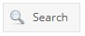 or press STRG+F. The following window opens:
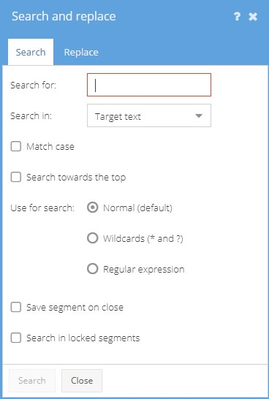
- Search for:
This field is for entering the text you are searching for.
- Search in:
Here you can specify whether you want to search in the source text or target text.
Search results in the source text are highlighted in yellow 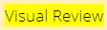 and in the target text in red . The segments containing the search hits open automatically. The number of hits is also indicated.
- Match case
Tick to perform a case-sensitive search.
- Search up
Tick to reverse the direction of the search, starting from the bottom and moving upwards.
- Use for search:
Define whether to search for the exact text (also as a fragment of another term), use wildcards (? and * are supported) or regular expressions.
(All PCRE regular expressions are supported, except some black-listed ones. For more information, please follow the link https://confluence.translate5.net/display/BUS/Search+and+replace and see the section on “Regular expression”.)
- Save segment upon closing
Automatically save segments opened during a search.
- Search in locked segments
Include locked segments when searching.
Click on the Replace tab to search for a word or text string and type the text which should replace said word or text string into the Replace field.
Click on the Search button at the bottom of the window to start the search and decide for each individual hit whether it should be replaced or not and click on Replace.
Be careful to only click on Replace all if you are certain that the text should be replaced in all cases. Replace all cannot be undone.
You can also select whether the changed segment should be automatically saved on closing.

Bookmark
Bookmarks help you navigate quickly to a specific location in the review document.
Click on in the Segment-editor panel to bookmark a segment.
To see only the bookmarked segments, click on at the top of the screen.

Quality management measures
You can tag text for quality management purposes. For example, you can mark whether a piece of text contains stylistic or grammatical errors and then perform statistical analyses based on this data. Select the relevant error categories by opening the Manual QA (inside segment) box in the Segment-editor panel.

Managing repetitions
translate5 includes a powerful auto-propagate function for handling text that occurs multiple times in the same document. To ensure that identical source text segments are translated consistently, translate5 automatically inserts the repeat translation. Note that this function applies only to entire identical segments and includes formatting tags.
When editing such internal repetitions, it is essential that changes are monitored carefully; in some cases, translations need to be different even if the source texts are identical.
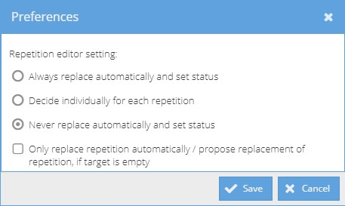
Using the Preferences button, you can adjust the behaviour of the repetition editor. The following options are available:
- Always replace automatically and set status
The open segment and all repeat occurrences are changed. The segment status is also changed in each case.
- Decide individually for each repetition (default setting)
A dialog box with a list of segments that contain the repetition is opened. You can now decide for each segment whether it needs to be changed or if the change should be rejected.
- Never replace automatically and set status
The change is applied only to the open segment and its status.
- Only replace repetition automatically / propose replacement of repetition if target is empty
The above options are only applied for sentences which have not been translated yet.

Terminology, style, grammar, and spelling
If a translation memory or other terminology database has been added to the task, translate5 shows you whether a segment contains a word which is included in any of these language resources.
Terminology hits are listed in the meta data section of the Segment-editor panel.
translate5 also indicates how the target-language terminology should be used. If the proposed word or phrase has been used correctly or not, it will either be highlighted or underlined in colour.
- If a word is underlined in blue, an associated term exists in the terminology and was used in the translation.
- Words underlined in red in the source text exist in the target language but were not used in the target text.
- If a word is marked with a red dotted line, it contains a spelling, grammar, or style error. Right-click on the word to see correction suggestions.
- A word underlined in brown exists in the source-language terminology but has not been defined for the target language.
- If a word is highlighted in purple, it is a misnomer, and its use is not recommended.

6. Leaving / Finishing the task
You can return to the Task Overview by clicking on the Back to task list button.
When leaving the task, you will be asked whether you want to finish it completely or simply close it and continue editing later.
The changes you have confirmed up to this point will be saved.
If you just want to pause editing, select Continue task later.
To finish the task completely, select All done – Finish task. After this, the task status in the Task Overview is set to “Finished”, and you will only be able to view the task in read-only mode.

7. Logging out
You can log out of the Editor by clicking on the Logout button in the Task Overview.
If you have any further questions, please visit the translate5 website via www.translate5.net or contact us via service@translate5.net. Have fun using the Editor.

Appendix I
Processing status
Processing status | Icon | Explanation
Translated |  | The segment has been translated but has not yet been edited by the reviewer. All segments generally have this status at the start of a review.
Not translated |  | The segment has neither been translated nor edited by the reviewer. Segments which are untranslated (by accident) have this status at the start of a review. For translation jobs this or “Pre-translated” is the initial status of a segment.
Pre-translated |  | The segment has been automatically translated, based on the associated TM.
Corrected |  | The segment has been changed and saved by the reviewer.
Autocorrected |  | After confirming the option to automatically adjust internal repetitions (see chapter 5), the segment was changed as if the reviewer had changed and saved a segment manually.
Locked |  | The segment is locked and cannot be edited  (e.g., it is a 100% match).
Unopened, confirmed |  | The segment has not been opened or changed by the reviewer. All segments that have not been opened are automatically assigned this status once the entire review is complete.
Opened, unchanged, confirmed |  | The segment was opened and saved without making any changes.
Opened, unchanged, autoconfirmed |  | After confirming the option to automatically adjust internal repetitions (see chapter 5), the segment was saved without making any changes because the reviewer also saved the first segment (i.e., the first time the segment occurs in the file) without making any changes.

Appendix II
Match rate types
Match type | Icon | Explanation
TM match |  | The translation for this segment comes from the translation memory and was not changed by the translator.
MT match |  | The translation for this segment comes from a machine translation engine. The engine name is shown in the tool tip, when hovering over the icon. The match rate comes from ModelFronts risk prediction (if used in this translate5 instance) or is set as a fixed value for the machine translation engine in translate5’s configuration.
Repetition |  | This segment occurs multiple times in the document. The translator has translated the segment and the translation was automatically entered into repeated segments.
Edited |  | 84% of the translation for this segment comes from the translation memory (it is an 84% match) and the translation was edited by the translator.
Edited |  | No match could be found for this segment in the translation memory. The segment was newly translated by the translator.
Source adopted |  | The source-language segment was taken over as the translation.
Document match |  | This translation comes from a bilingual predecessor document.
Alignment |  | The translation comes from an alignment. An alignment is a process whereby a source-language document and a target-language document are displayed next to one another in a computer-assisted translation program, and the translator matches up the segments with each other. The linked segments are then imported into a translation memory.

